**Lab Assignment 3.2**

**----------------------------------------------------------------------------------**

**Task Description#1  
● Ask AI to write a function to calculate compound interest, starting with only the  
function name. Then add a docstring, then input-output example  
Expected Output#1  
● Comparison of AI-generated code styles**

**Prompt:**

**Generate a dynamic python function to calculate compound interest, starting with only the function name, add docstring. Give output also**

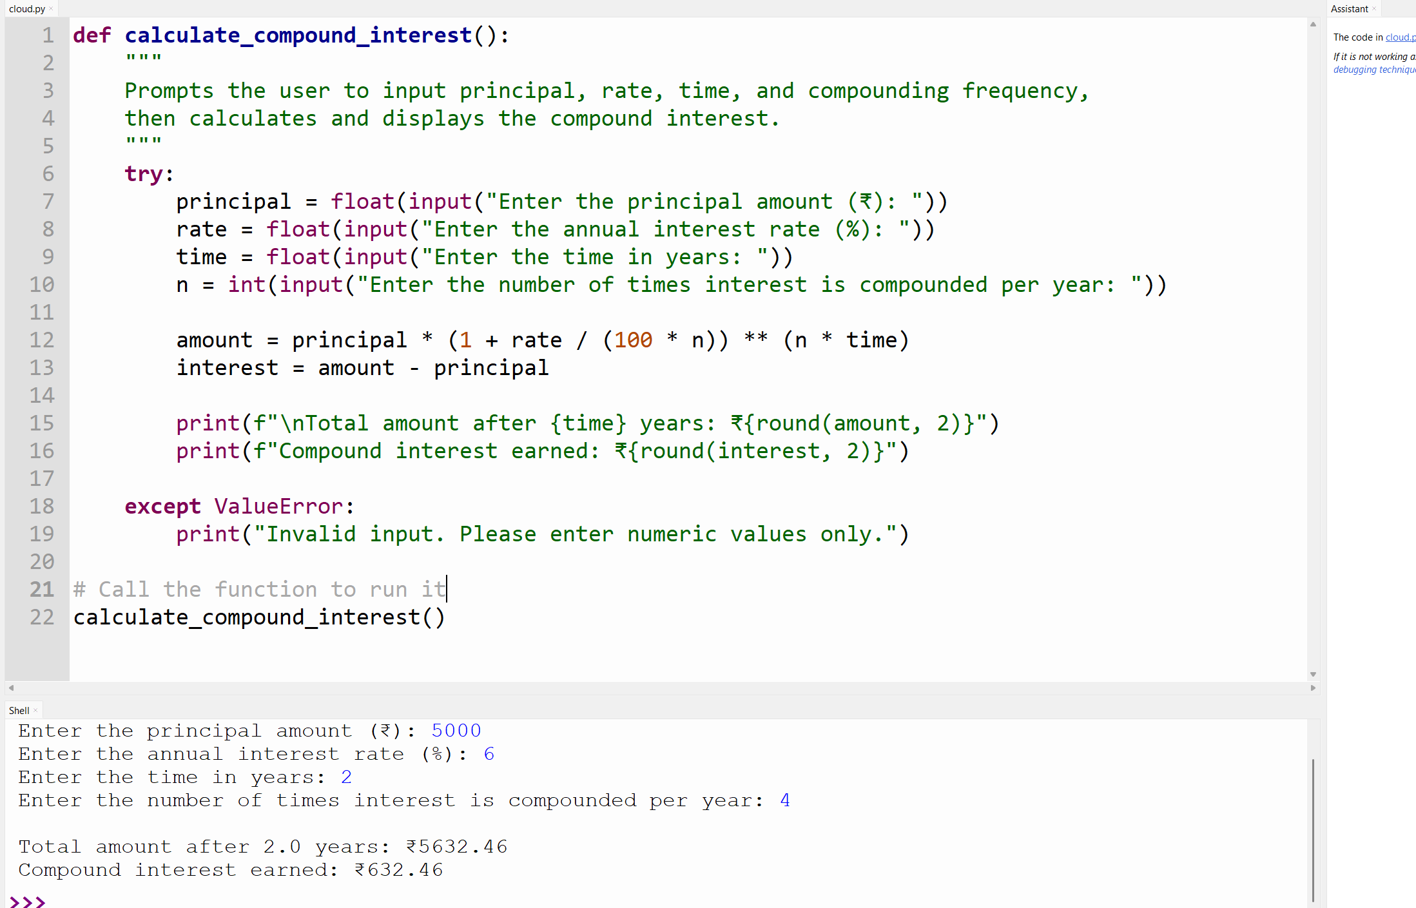

**Task Description#2  
● Do math stuff, then refine it to: # Write a function to calculate average, median, and  
mode of a list of numbers.  
Expected Output#2  
● AI-generated function evolves from unclear to accurate multi-statistical operation.**

**Prompt:Generate a python function code which asks input for list of numbers from user calculate average, median, and  
mode of a list of numbers. Give output**

**P2:** **write a python function code to calculate average, mean, median and mode from a given list. It should take input from user. Give output also**

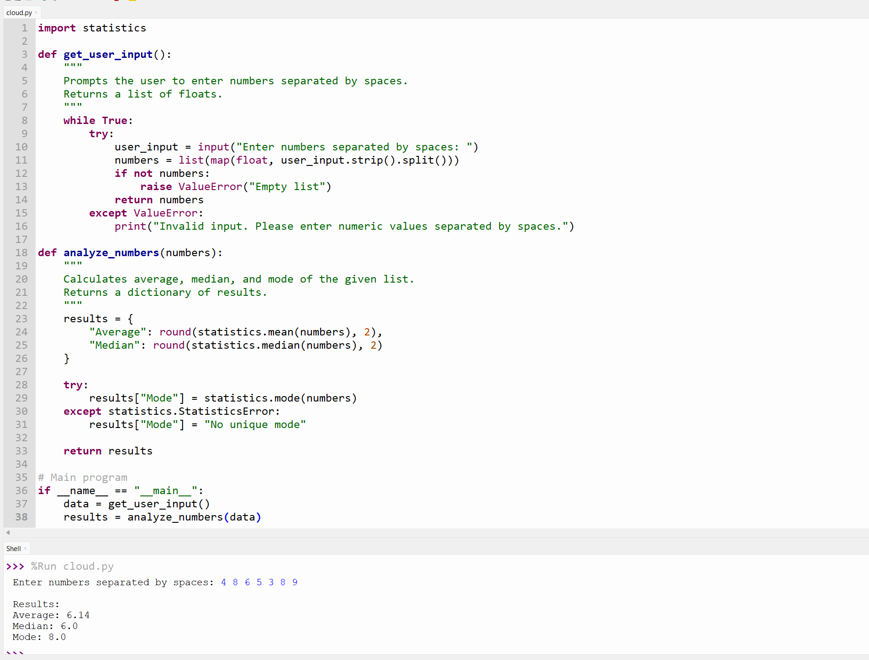

**Task Description#3  
● Provide multiple examples of input-output to the AI for convert_to_binary(num)  
function. Observe how AI uses few-shot prompting to generalize.  
Expected Output#3  
● Enhanced AI output with clearer prompts**

**Prompt:**

**Generate a python code to convert a number to a binary number . It should take input from user and give output**

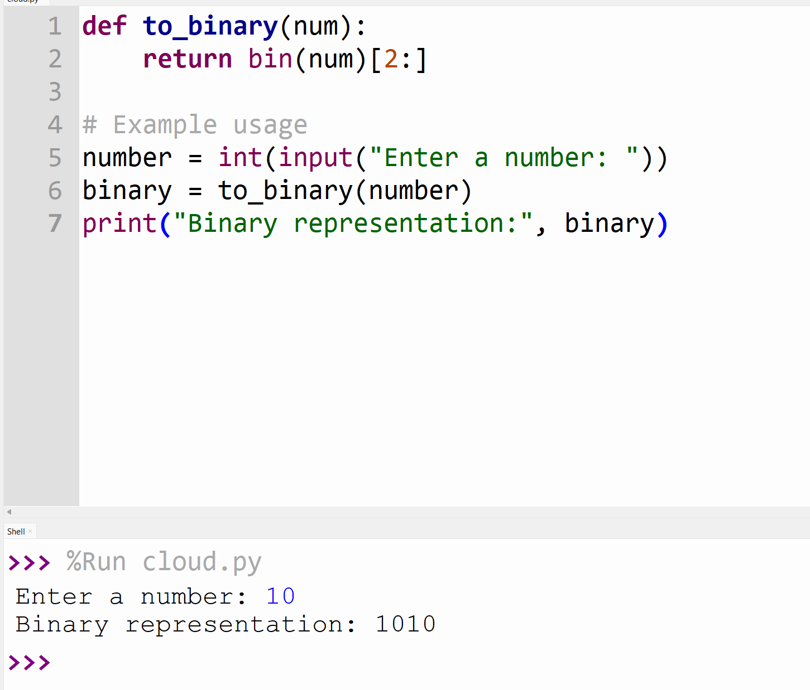

**Task Description#4  
● Create an user interface for an hotel to generate bill based on customer requirements  
Expected Output#4  
● Consistent functions with shared logic**

**Prompt:**

**Generate a user interface python function code for an hotel to generate bill based on customer requirements. The bill should include tax also**

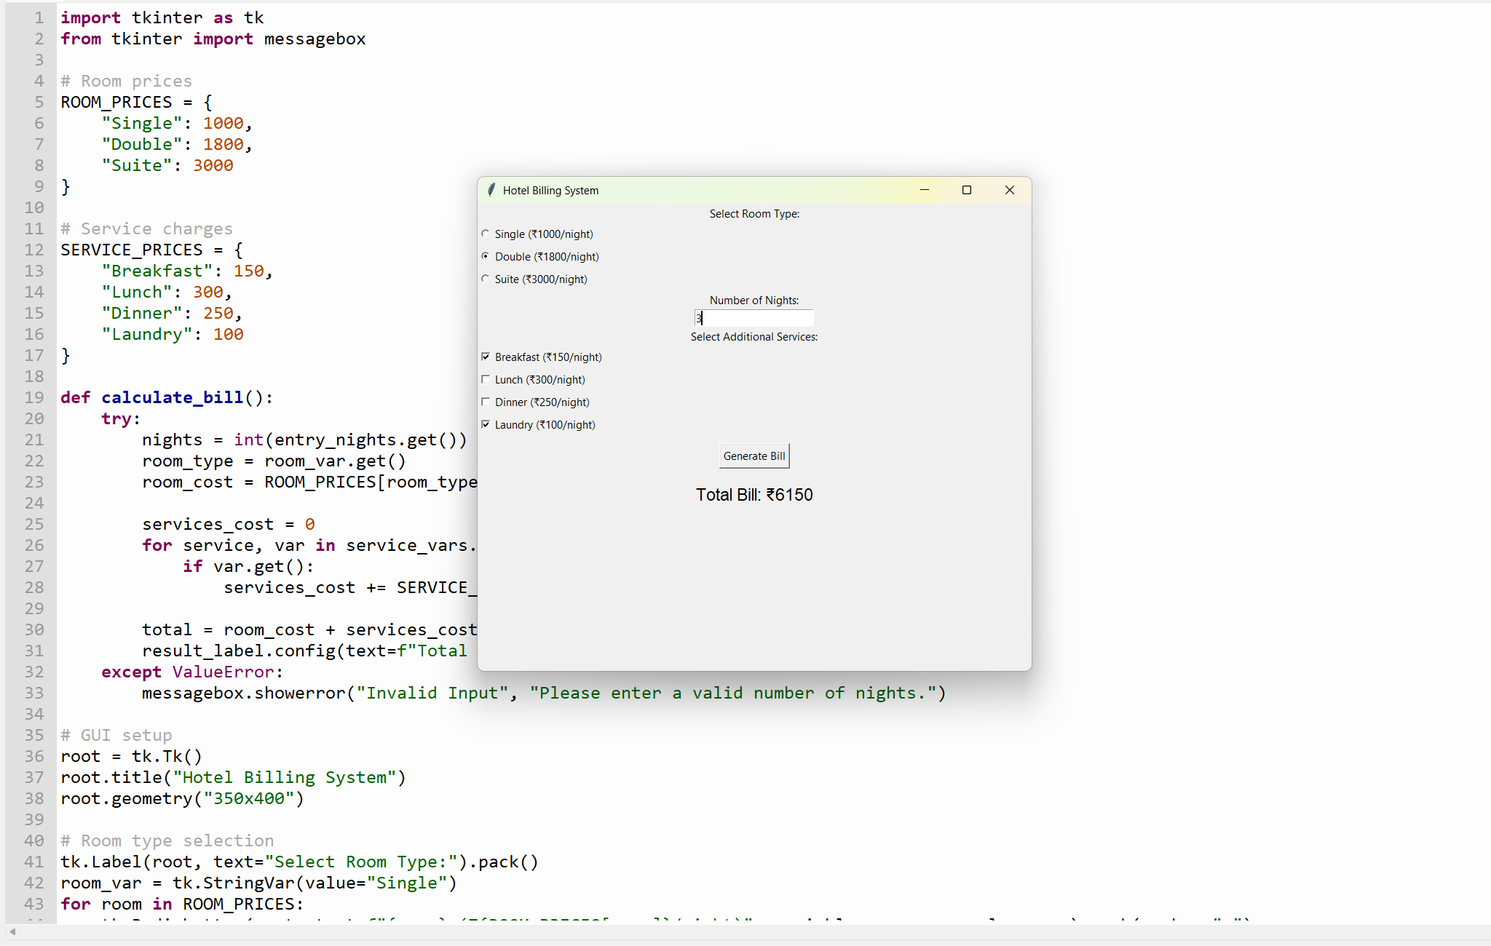

**Task Description#5  
● Analyzing Prompt Specificity: Improving Temperature Conversion Function with  
Clear Instructions  
Expected Output#5  
● Code quality difference analysis for various prompts**

**Prompt:Generate a python function code to convert temperature. It should convert from one temperature to another**

